1-

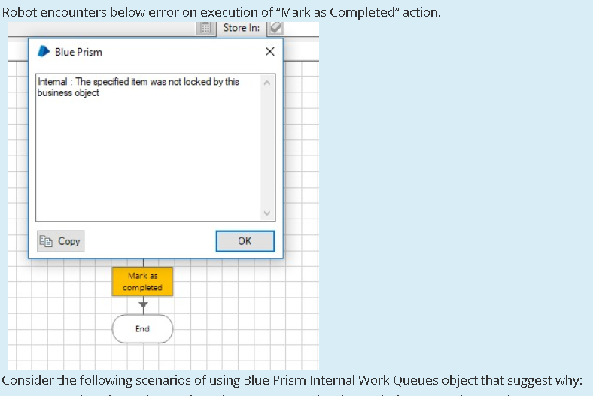

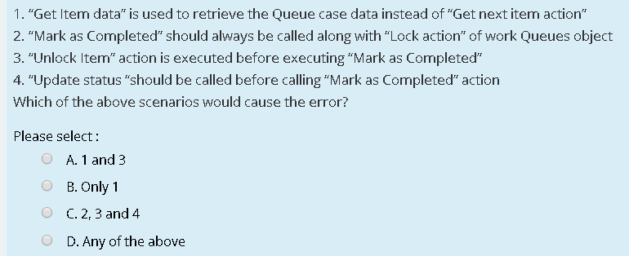

2-

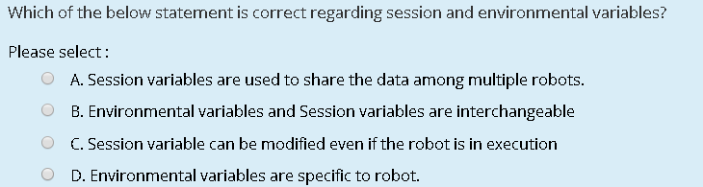

3-

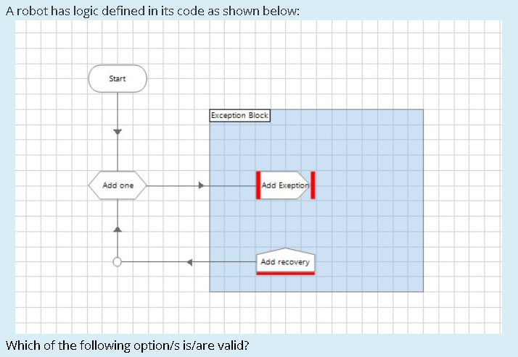

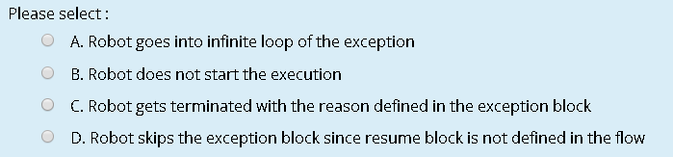

4-

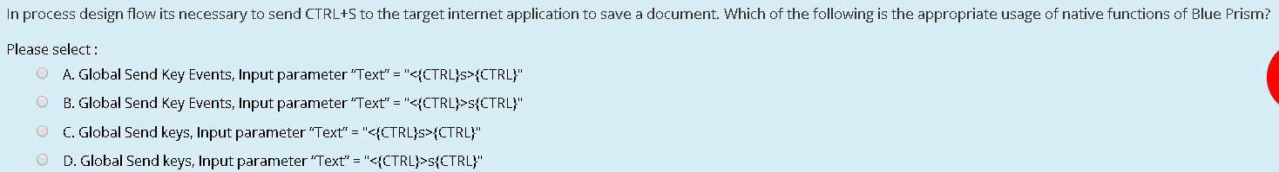

5-

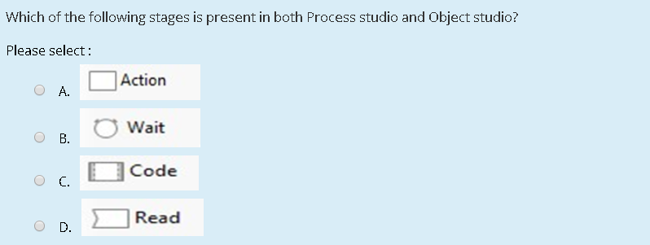

6-

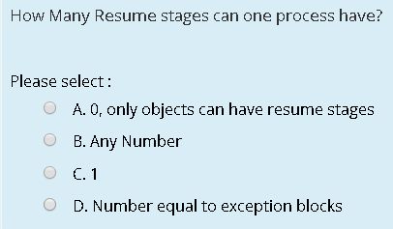

7-

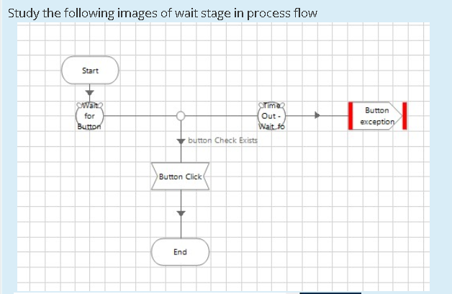

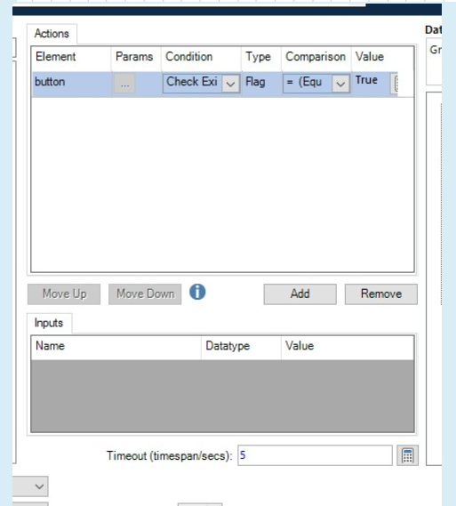

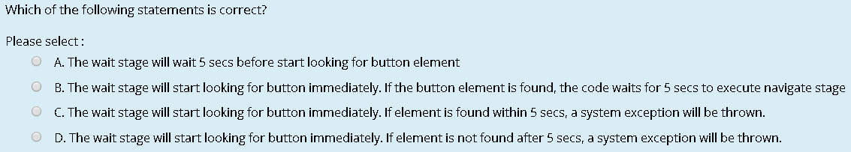

8-

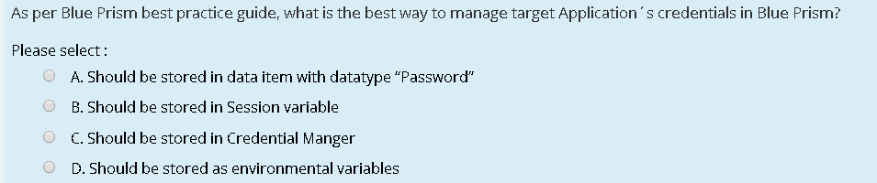

9-

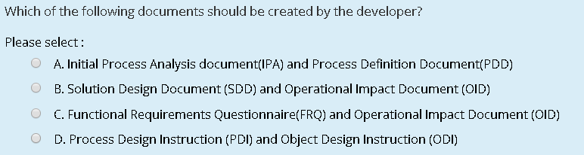

10-

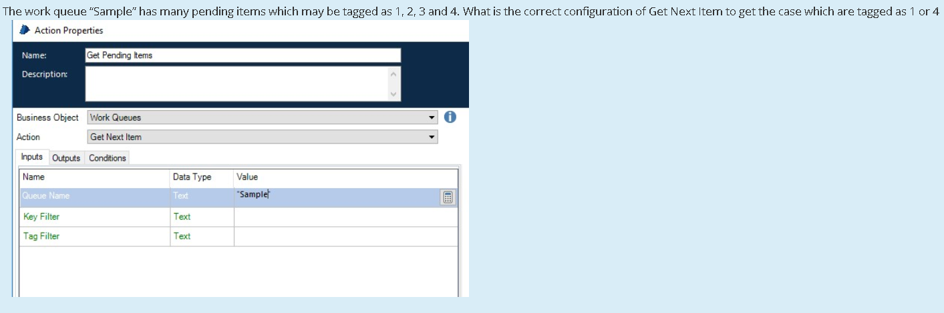

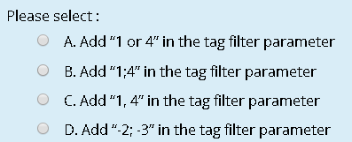

Answer:

ACCAA

BDCDD

No.9 Detail:

|  |  |
| --- | --- |
| Document | Created By |
| Initial Process Analysis | Blue Prism analyst or developer |
| Process Definition Document | Client SME and/or Blue Prism analyst |
| Functional Requirements Questionnaire | Client SME and/or Blue Prism analyst |
| Solution Design Document | Blue Prism developer |
| Operational Impact Document | Blue Prism analyst |
| Process Design Instruction | Blue Prism developer |
| Object Design Instruction | Blue Prism developer |